**How to Mass Erase and FLASH**

1). Enable UCB and DFLASH1 programming from Hardware->Options

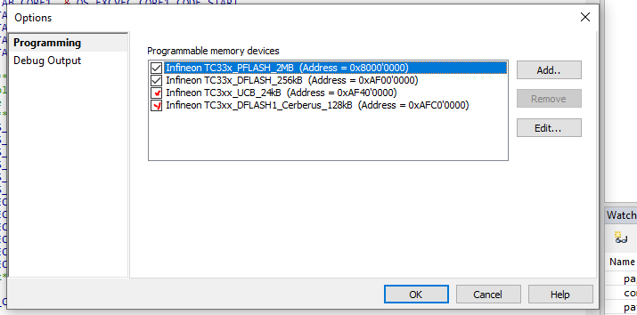

2) Add to target files disable_HSM, enable_HSM_0x80000000_0x80004000_0x80008000_0x8000B000 and Init_Dataflash(found in S:\Tools\Vector_configuration\Workspace\hsm\Support)

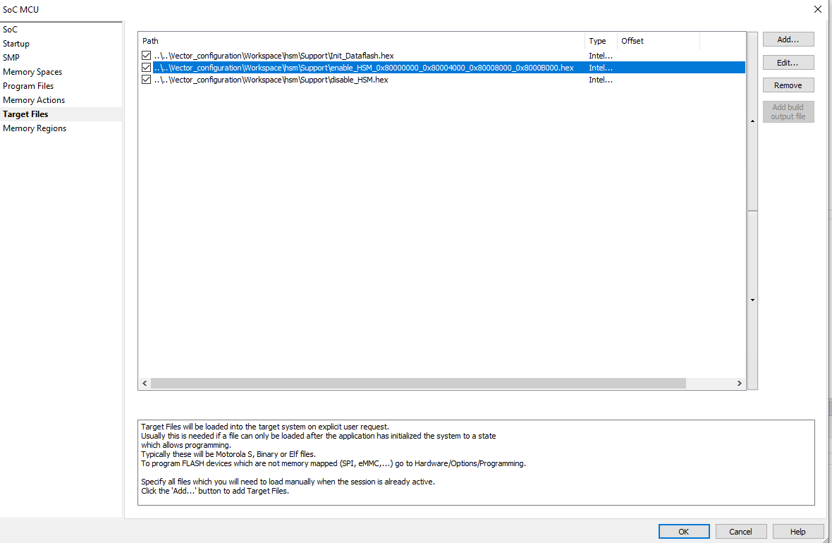

3) Perform a reset 

4) Download disable_HSM.hex; Debug->Target download

5) Perform a reset 

6) Mass erase PFLASH,FLASH and DFLASH1:

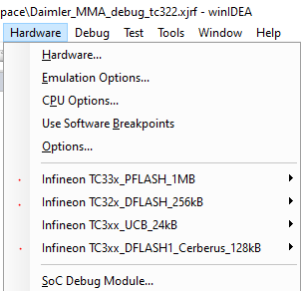

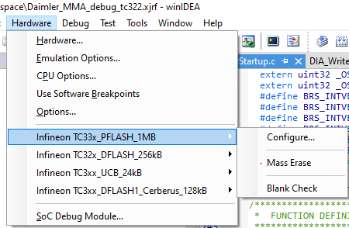

7) Perform a reset 

8) Download the binaries: app.hex, bm.hex, fbl.hex and hsm.hex, hsm_upd.hex 

9) Perform a reset 

10) Target download Init_Dataflash.hex

11) Perform a reset 

12) Target download enable_HSM_0x80000000_0x80004000_0x80008000_0x8000B000.hex

13) Perform a reset 

14) Disable UCB and Dflash1 programming from Hardware->Options ( For safety)

•For regular programming (no mass erase required) only step 8) has to be performed.

•If the uC is brand new only steps 8-14 have to be performed.